Q1.
Answer is B.

A: Excludes employees without departments.
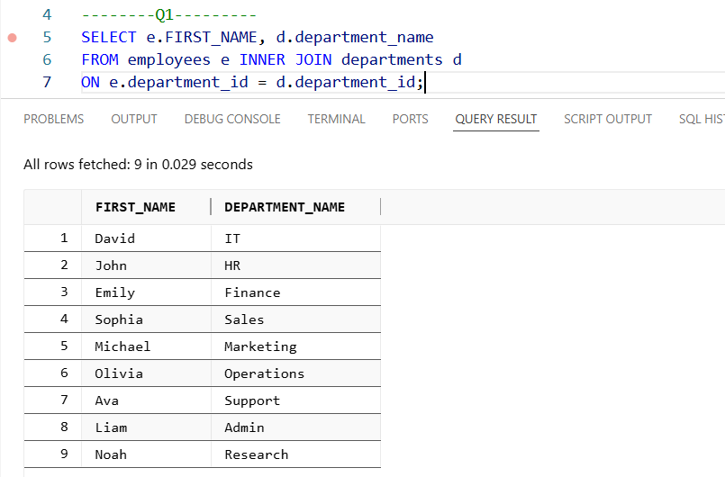

B: Includes all employees, even without departments.
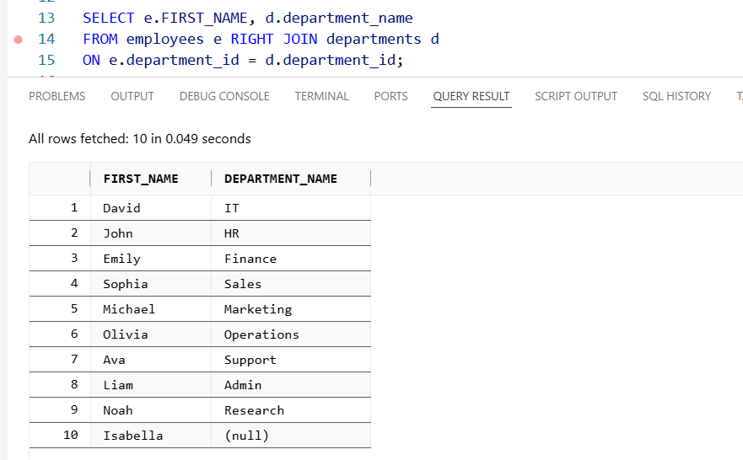

C: Includes all departments, not all employees.
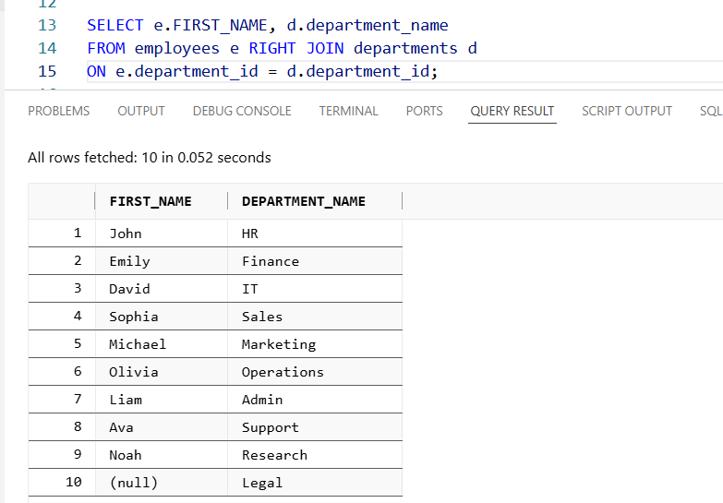

D: Includes employees without departments but also adds unused departments.
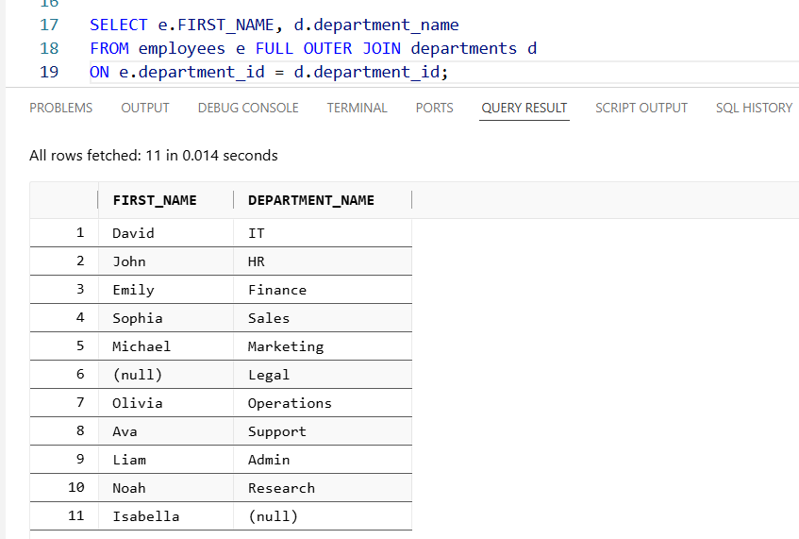

Q2.
Answer is B.

A: Excludes customers without orders.
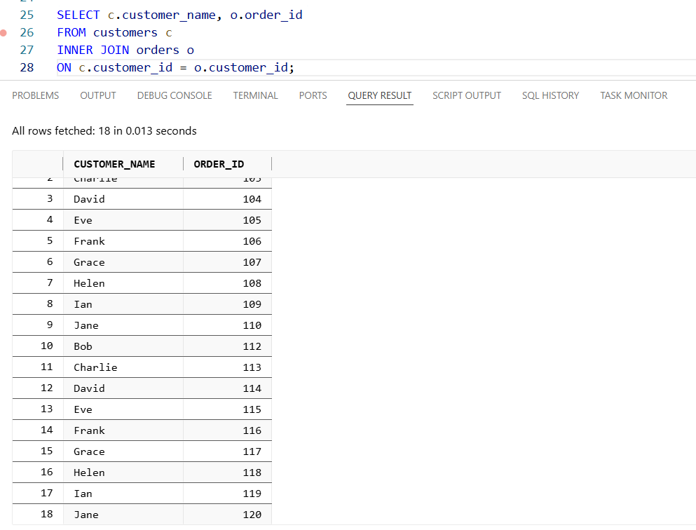

B: Includes all customers, even without orders.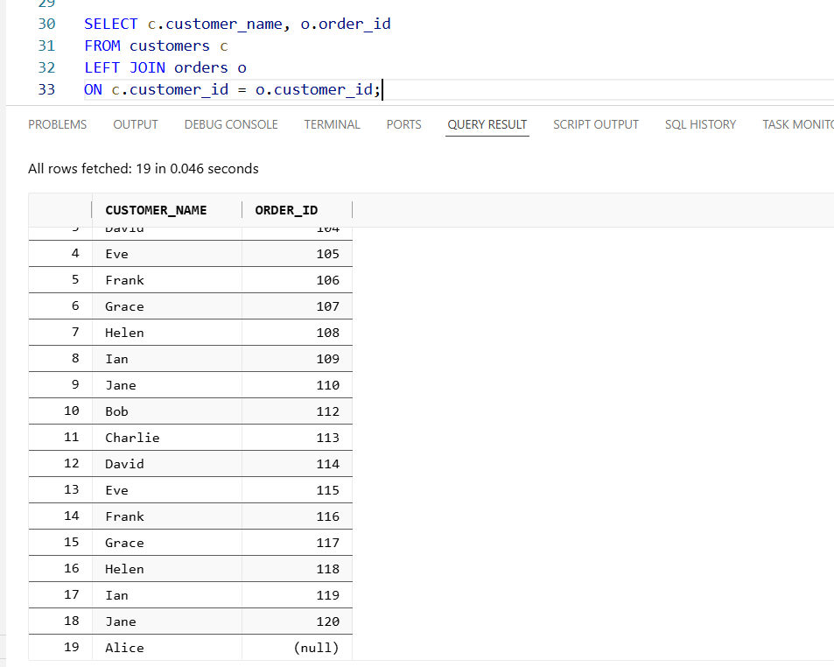
C: Includes all orders, not all customers
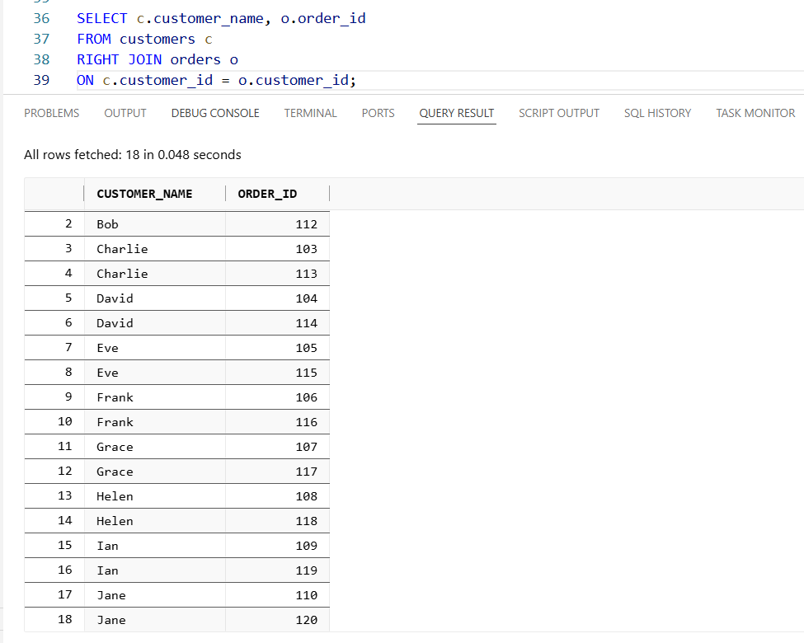

D: Includes customers without orders but also adds unused orders.
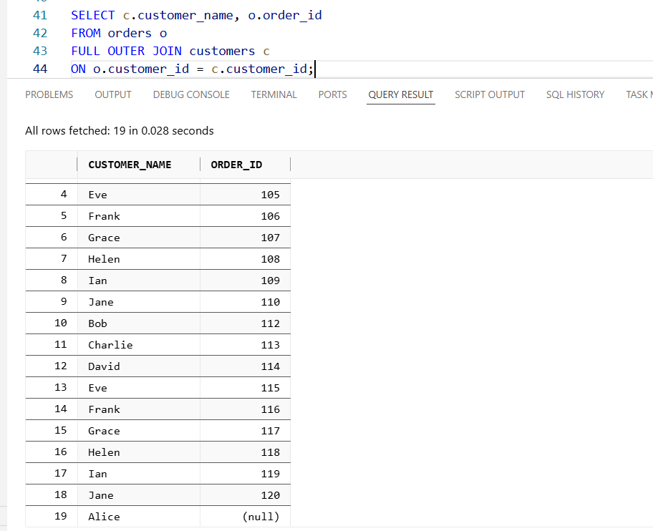

Q3.
Answer is B.

A: Excludes books never borrowed.
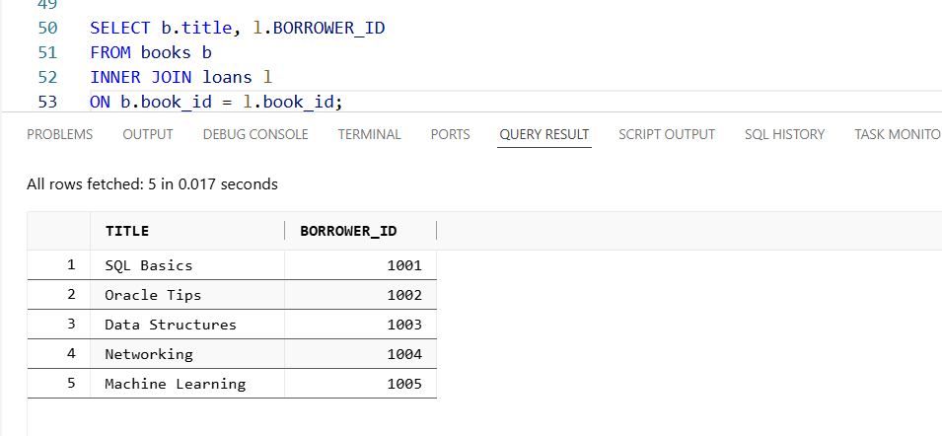

B: Includes all books, even without borrowers.
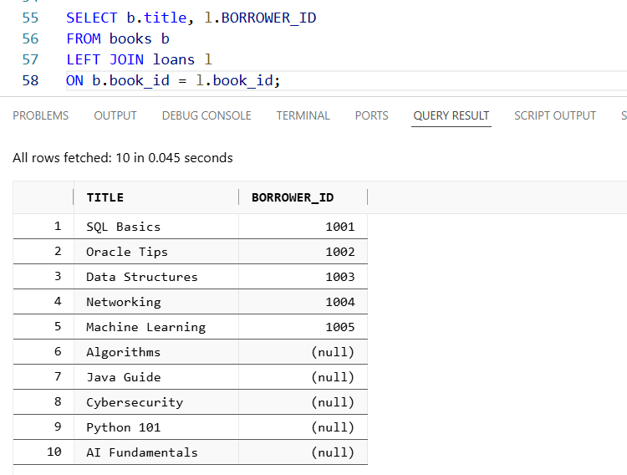

C: Also Correct. Equivalent to LEFT JOIN but less conventional.
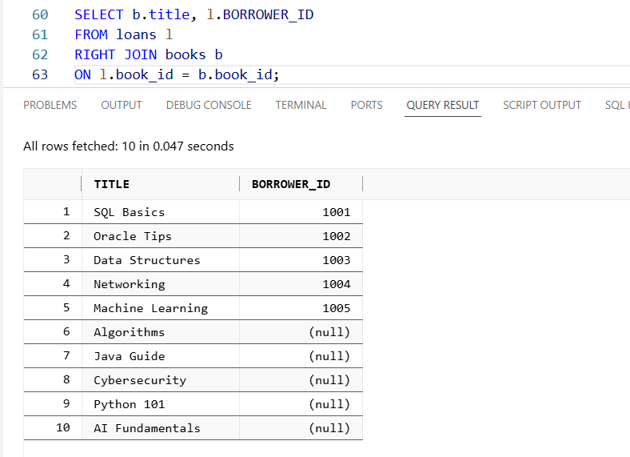

D: Includes books without borrowers but also adds unused loans.
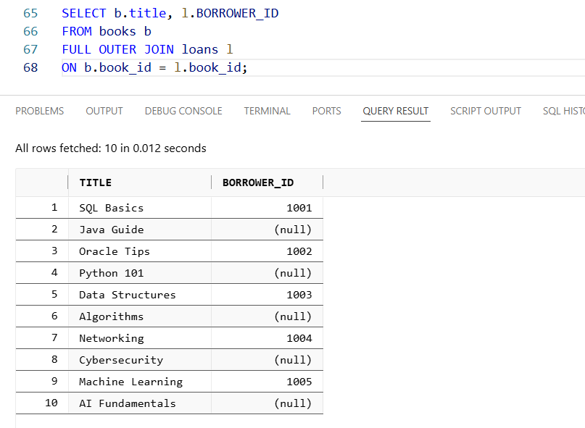

Q4.
Answer is B.

A: Excludes products never sold.
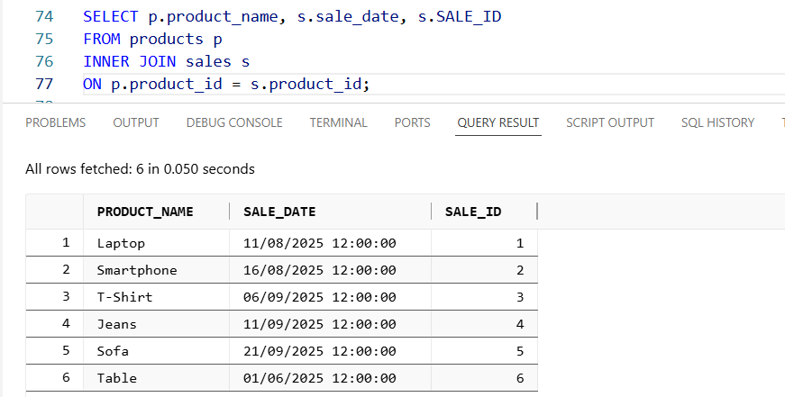

B: Includes all products, even without sales.
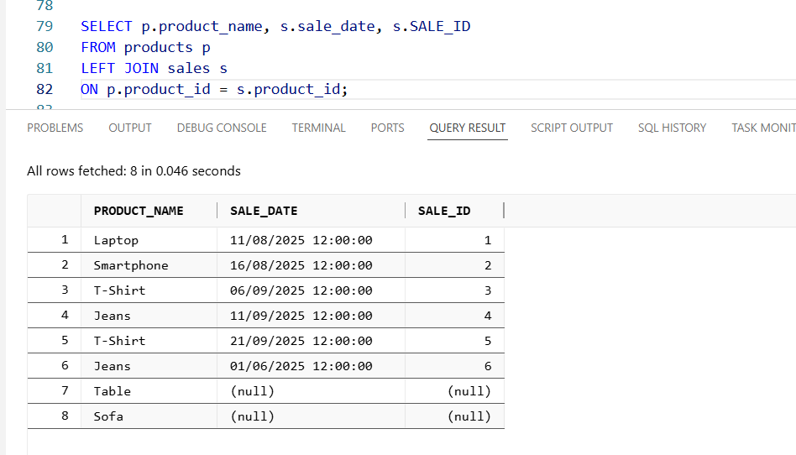

C: Also Correct. Equivalent to LEFT JOIN but less conventional.
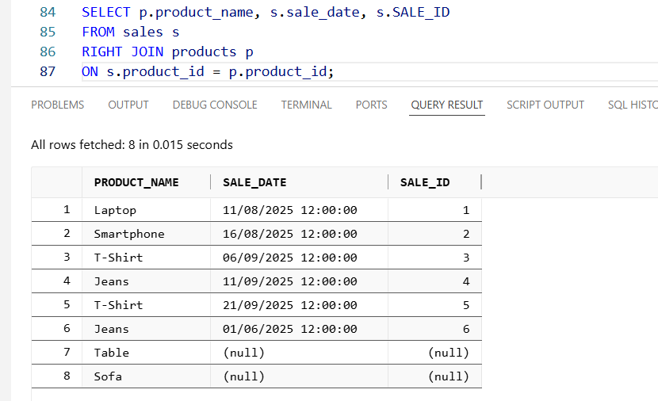

D: Includes products never sold but also adds unused sales.
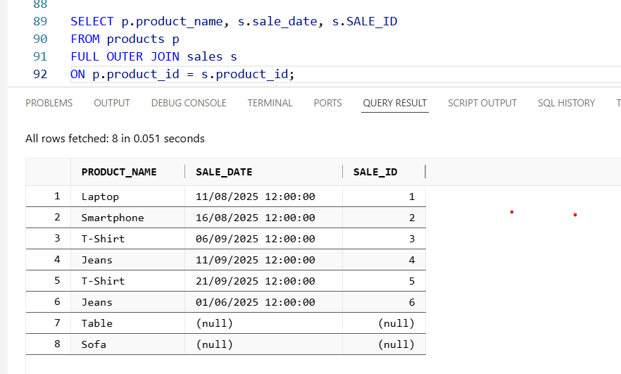

Q5.
Answer is

A: Excludes projects with no assignments.
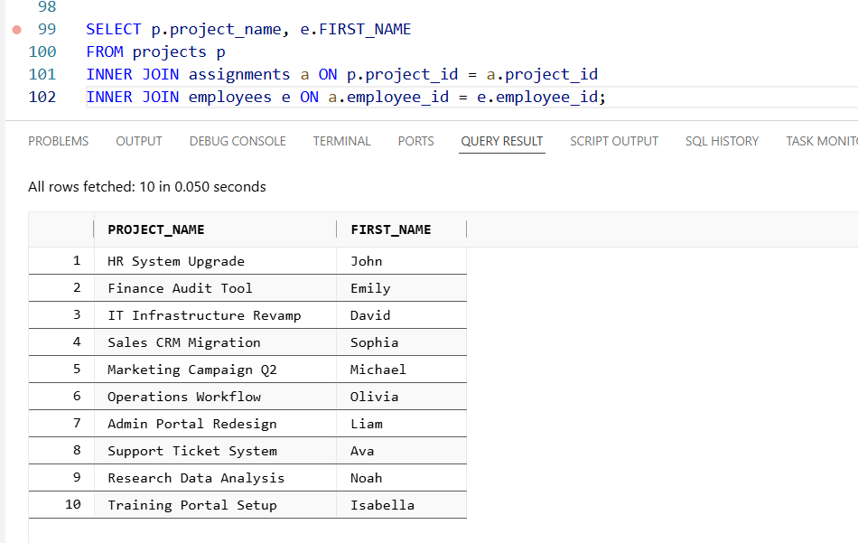

B: Includes all projects, even without assignments.
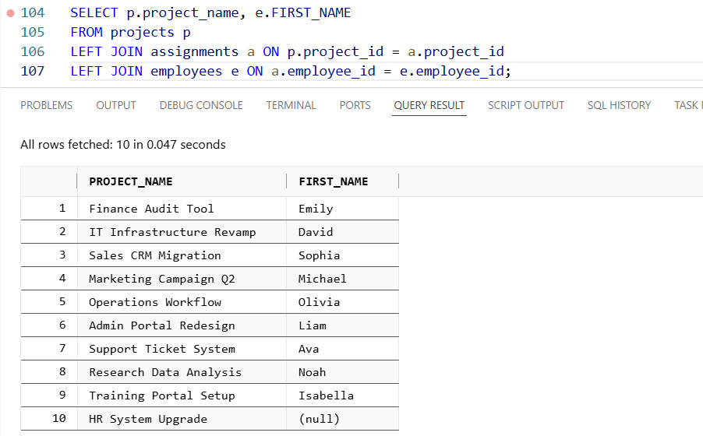

C: Could work but is less conventional and harder to read.
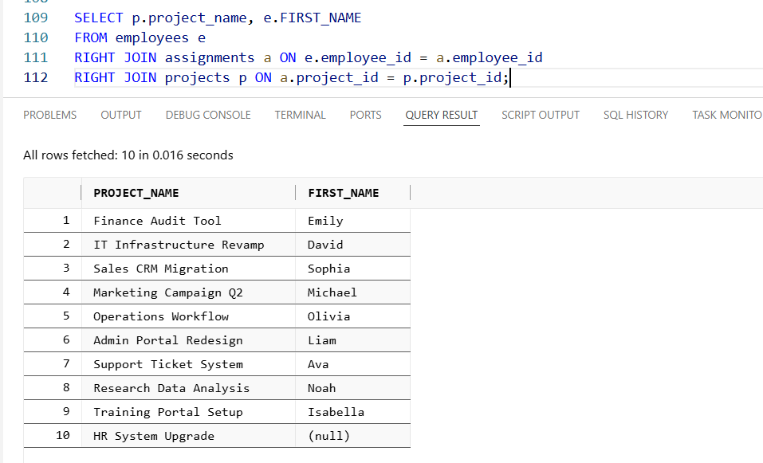

D: Includes projects but also adds unwanted employee/assignments.
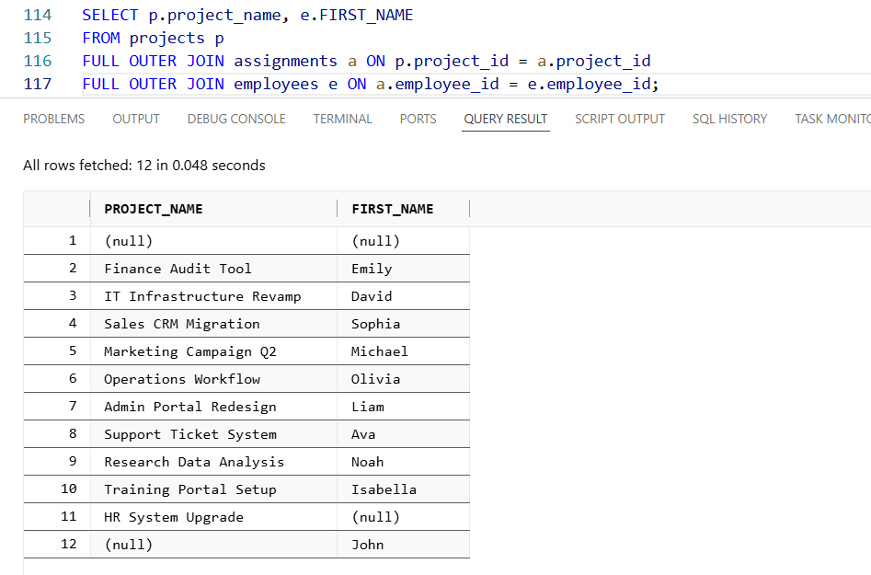

Q6.
Answer is B.

A: Excludes ticket with no customer.
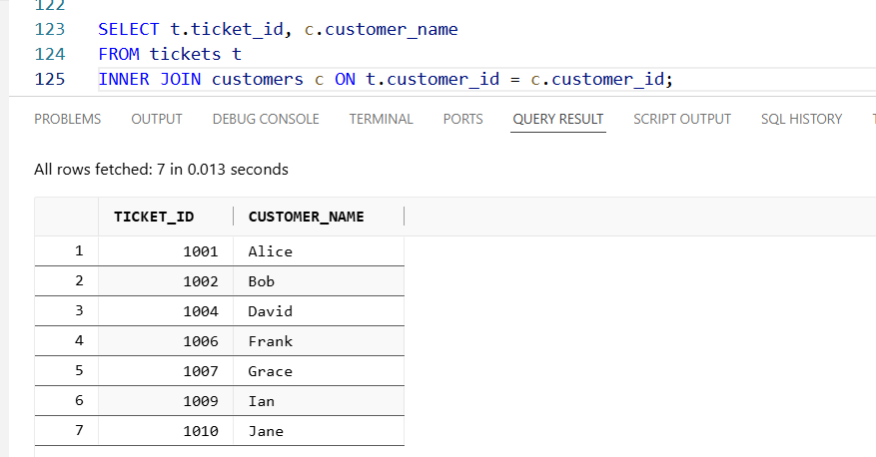

B: Includes all tickets ,even without customer.
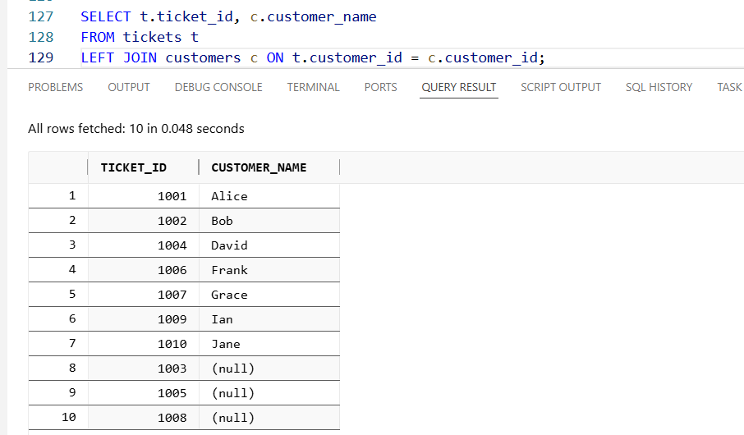

C: Also work but less useable and harder to read.
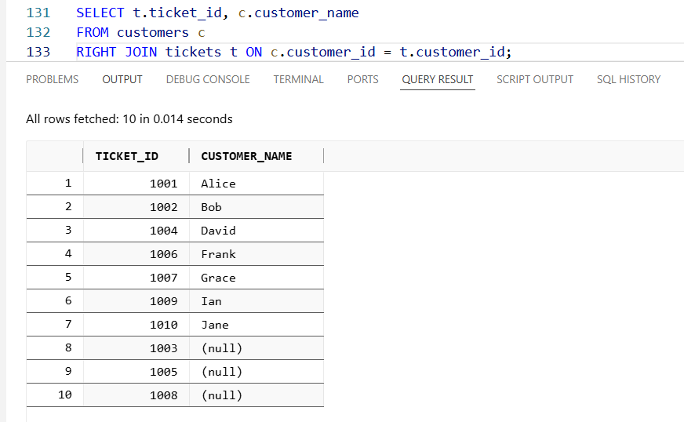

D: Includes all tickets but also adds unused customer.
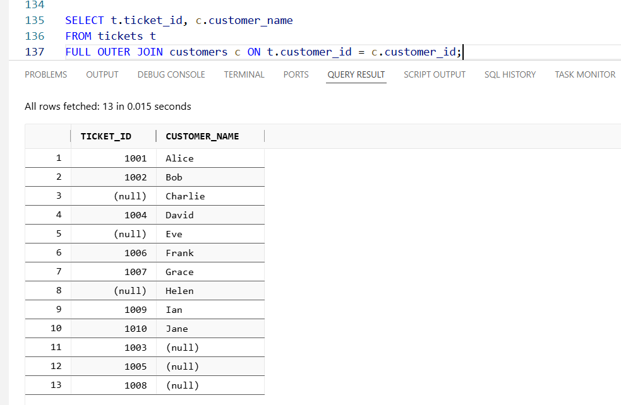

Q7
Answer is B.

A: it excludes courses with no students.
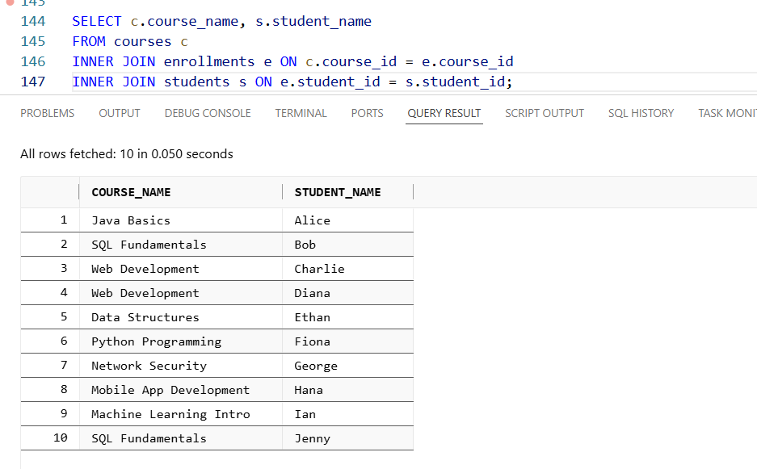

B: It includes all courses, even without student.
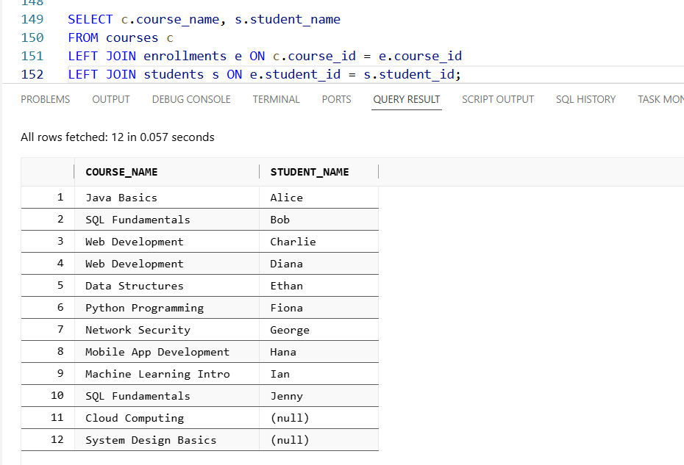

C: Also work but less useable.
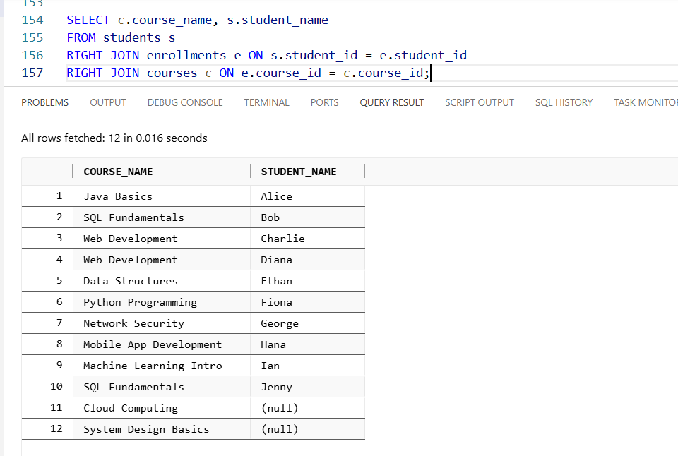

D: It includes all courses but also adds unused students.
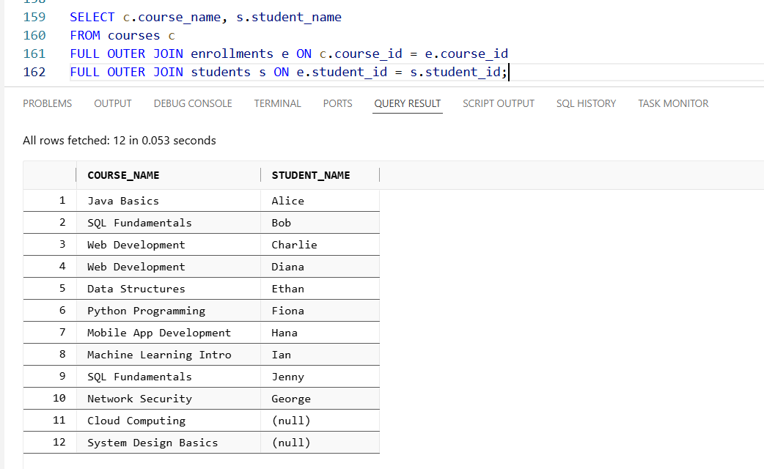

Q8.
Answer is B.

A: It excludes all products with no supplier.
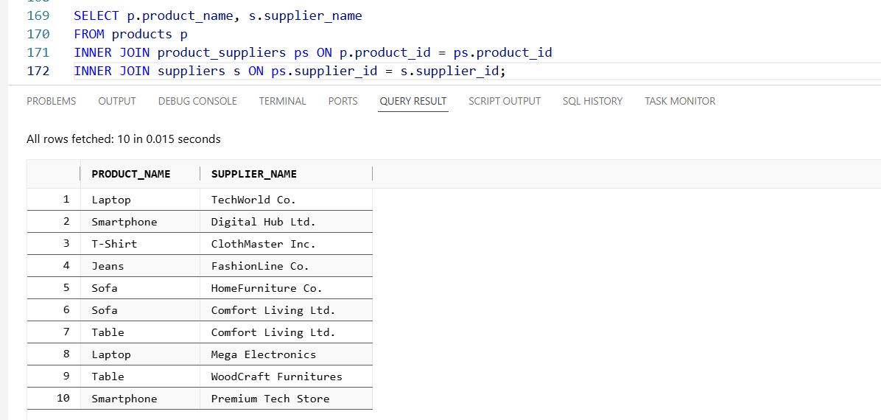

B: It includes all products, even without supplier.
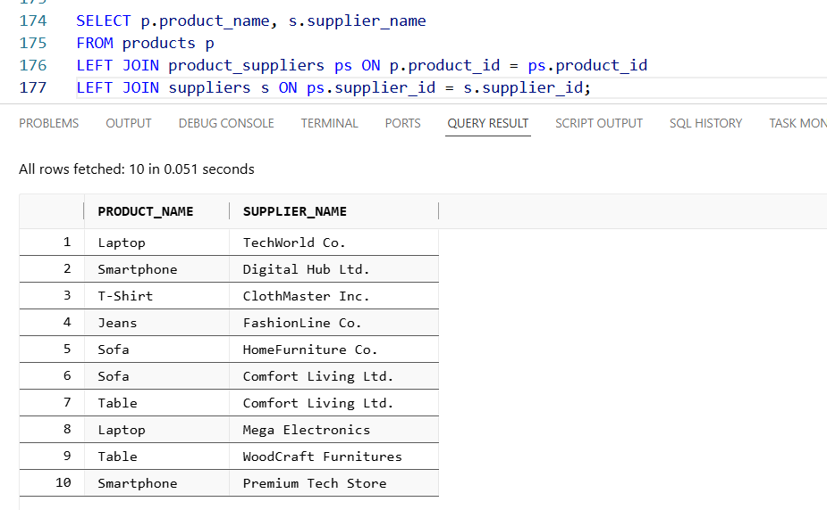

C: Also work but less useable.
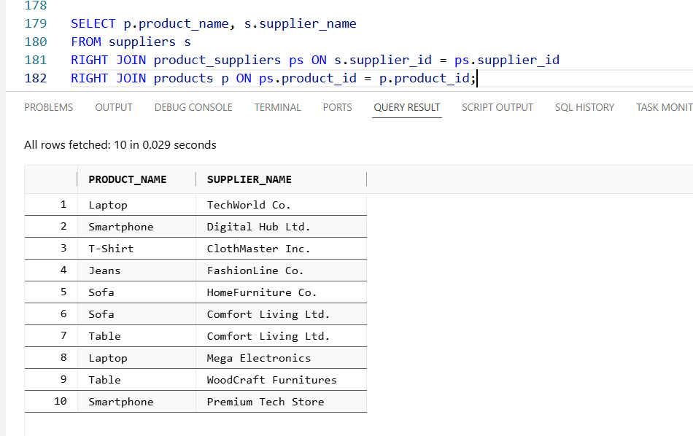

D: It includes all products but also adds unused supplier.
